**Experiment No. 06**

**Aim: To study and implement File Handling in Python.**

**Code:**

**Part A:**

print("Enter 10 numbers")

with open('t1.txt','w') as f:

for i in range(9):

f.write(str(input("Enter a number"))+ "\n")

f.write(str(input("enter a number"))+ "\n")

with open ("t1.txt","r") as f1 , open ("t2.txt","w") as f2:

l= list()

for i in f1:

l.append(int(i))

l.sort()

for i in range(10):

f2.write(str(l[i])+ "\n")

**File 1:**  **File 2:**

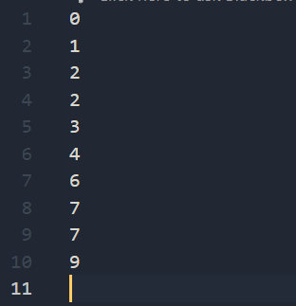

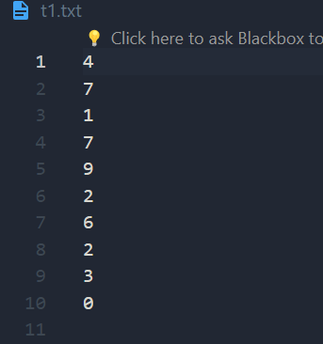**Part B:**

fileread=open('t1.txt','r')

list=list()

f=fileread.read()

f=f.split(' ')

for line in f:

list.append(str(line))

list.sort(key=lambda item:(item,len(item)))

print('Sorted in Lexographical order')

print(list)

filewrite=open('t2.txt','w')

for i in list:

filewrite.write(str(i))

filewrite.write('\n')

filewrite.close()

**File to sort:**  **Sorted File:**

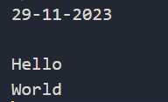

**Part C:**

fileread=open('t1.txt','r')

list=list()

f=fileread.read()

f=f.split(' ')

for line in f:

list.append(str(line)[::-1])

list.sort(key=lambda item:(item,len(item)))

print('Sorted in Lexographical order')

print(list)

filewrite=open('t2.txt','w')

for i in list:

filewrite.write(str(i))

filewrite.write('\n')

filewrite.close()

**Sorted File:**

